BACKEND SKILL PROGRAMS
SKILL - 1
1. Create Table
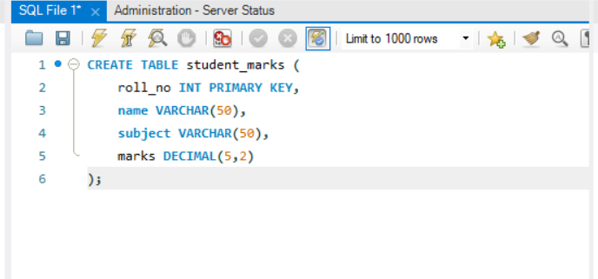
2. Insert Data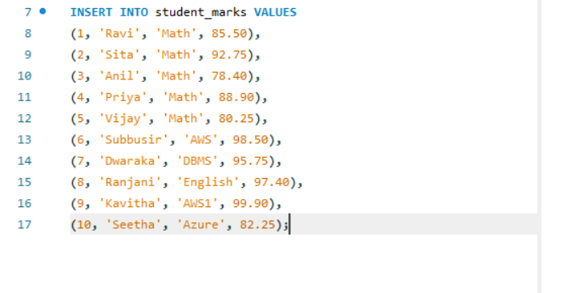
3. Display All Records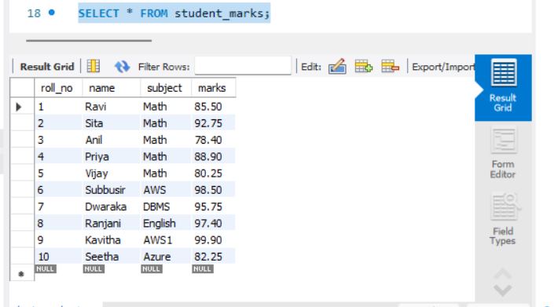
4. Aggregate Functions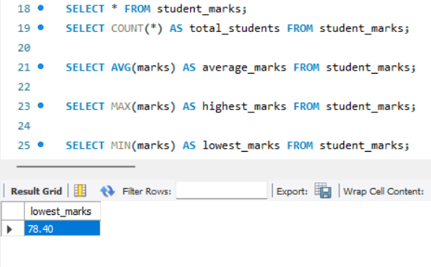
5. WHERE Condition
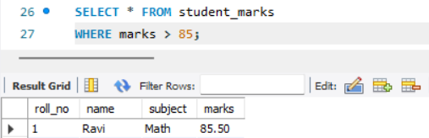
6. BETWEEN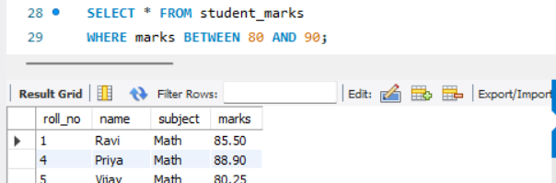
7. LIKE
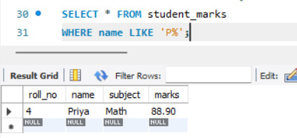
8. UPDATE
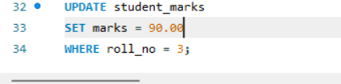
9. DELETE

10. Sorting
